1. Identify class level, specify whether core, elective, or major requirement, any other pertinent information on class demographics.

My BRIDGE project focused on the freshmen biology course (Biology 115) which is the first-semester core course taken by all biology majors. There are typically 75 to 80 students in this course, the majority of which are freshmen biology majors. Other students that typically take this course include marine science and environmental science majors (often freshmen) and education majors (often upper classmen). The course has been team-taught for several years by at least 2 biology faculty (Drs. Drawbridge and Weber) and I was added to the team in 2002. In the fall of 2006, we began an experiment on the influence of class size on student performance by splitting the course into two, approximately equal-sized sections taught consecutively (Monday, Wednesday and Friday). Unfortunately (?), our enrollment also increased in 2006 to approximately 90 students and as a result each section was approximately 45 students; not as significant a reduction in class size as we were hoping for.
I thought that this experiment provided a unique opportunity to also examine the influence of teaching techniques on student learning and (therefore?) performance by teaching the same concepts in each course section but using different teaching techniques. Specifically, I used two small group activities versus lecture via questioning. The first small group activity dealt with the concepts of adaptation (e.g., predation and anti-predation), forming hypotheses and designing experiments to test hypotheses, the second examined the factors influencing the spatial distribution of organisms.

2. What problems or questions about my students’ learning and my teaching strategies did I address?

In theory, group activities facilitate learning by allowing students to generate discussion amongst themselves and lead to peer teaching at a level not easily obtained in a more traditional (or even progressive) lecture format. Thus, students who learn better by attacking a defined problem through discussion of ideas may benefit from group activities. While I have not used small group activities during the lecture portion of my courses, I have colleagues who consider them a very effective teaching strategy. So, I am interested in learning if small group activities are a useful tool for my own teaching.

3. What methods did I use to gain information?

I asked a number of colleagues who use group activities for suggestions on how to incorporate these activities into my curriculum.

4. What examples or evidence of student performance can I offer to illustrate how I drew conclusions?

I used two small group activities (each in different sections of the course). Each activity had a problem for the students to solve on a worksheet that was to be handed in at the end of class (see attached examples). All students, regardless of teaching technique, worked on virtually the same assignment. In the section where students were broken into groups (~8 students/group) each group handed in one worksheet. In the section where students received only lecture via questioning, each student handed in his or her own worksheet. The first group exercise was carried out on a Monday and at the end of that week (Friday), both sections were given a quiz (see attached). The second group activity was carried out shortly before the last semester exam and final exam.

5. What theories or debates about learning frame or illuminate my inquiry?

For the most part, my project sought to identify expert practices and help students make progress on the curve from novice to expert in biology by giving them practice in forming hypotheses and designing experiments to test hypotheses and interpreting graphical data and drawing conclusions from those interpretations.

6. What have I learned (or what new hypotheses have I developed) so far?

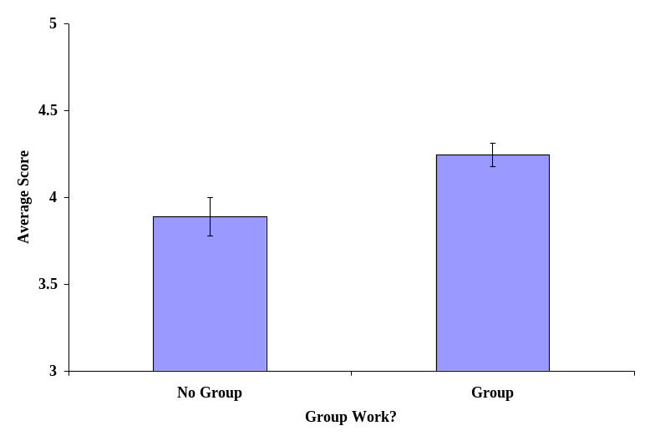
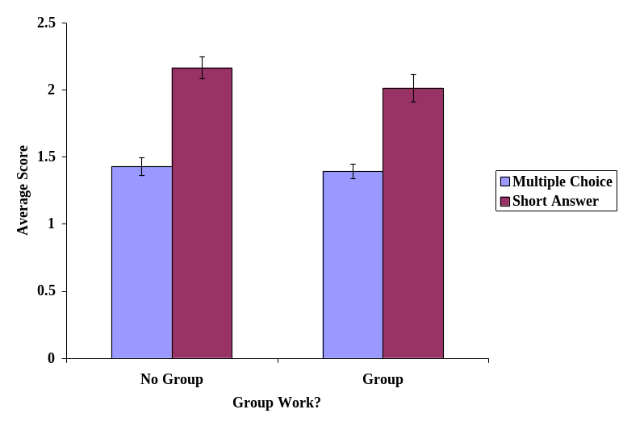
The data suggest that while students in groups had slightly better (~10%) average scores on the in-class assignment (Figure 1), they did not have better scores on either the multiple choice section or short answer section of the quiz (Figure 2). There was also no evidence to indicate that students who participated in group activities performed better on the semester exam which included the same material.
Figure 1. Average (+1 standard error) scores on the in-class assignment for students who worked in groups versus individually. The assignment was worth 5 points.
Figure 2. Average (+1 standard error) scores on the quiz for students who worked in groups versus individually. The scores on the multiple choice and short answer sections of the quiz are shown separately. The quiz was worth 5 points.

I also have a better understanding of how group activities can be used as a teaching tool and have ideas for improving these activities in the future. For example, the activities may be more productive by providing more structure or guidelines for the group activities and more opportunities for groups to present their results to the rest of the class.

7. Where will I go from here?

Our experiment with smaller class size will continue in 2007, therefore I plan to refine the group activities and perhaps add one more because I still think they have the potential to be effective teaching strategies.
BIO 115
Group Activity #1
Group Members:
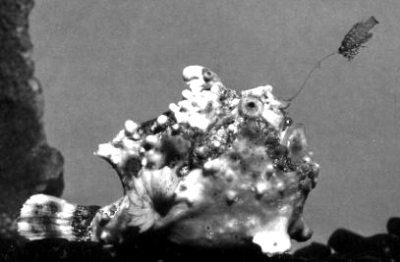

Questions:
1. What type of organism is this? (I am not looking for it’s species name: is it a bird?...an insect?...)

2. Hypothesize why this organism looks the way it does. (Hint: there is only ONE organism shown in
this image)

3. If you could make unlimited observations of this organism in the field, what data or observations would support your hypothesis in #2?

4. Describe an experiment, either in the field or laboratory that tests your hypothesis. Remember, an experiment means that you MANIPULATE something.

BIO 115: FALL 2005

QUIZ
NAME__________________________________________

Multiple Choice: Circle the BEST response. (half a point each)

1. Which of the following is a plant adaptation to prevent herbivory?
A. low C:N ratio
B. cellulose
C. dropping leaves in fall
D. toxins
E. A and C
F. B and D
G. all of the above

2. Which of the following is an herbivore adaptation to successfully eat plants?
A. multiple stomachs
B. fast running speeds
C. resistance to plant toxins
D. forming groups
E. A and C
F. B and D
G. all of the above

3. Which of the following is an adaptation for successfully acquiring food seen in BOTH herbivores
and carnivores?
A. multiple stomachs
B. resistance to toxins
C. broad, flat teeth
D. fast running speeds
E. B and D
F. all of the above

4. Which of the following is an adaptation used by predators (for successfully acquiring food) and by
prey (as an anti-predation adaptation)?
A. camouflage
B. forming groups
C. fast running speeds
D. A and C
E. all of the above

Short Answer.
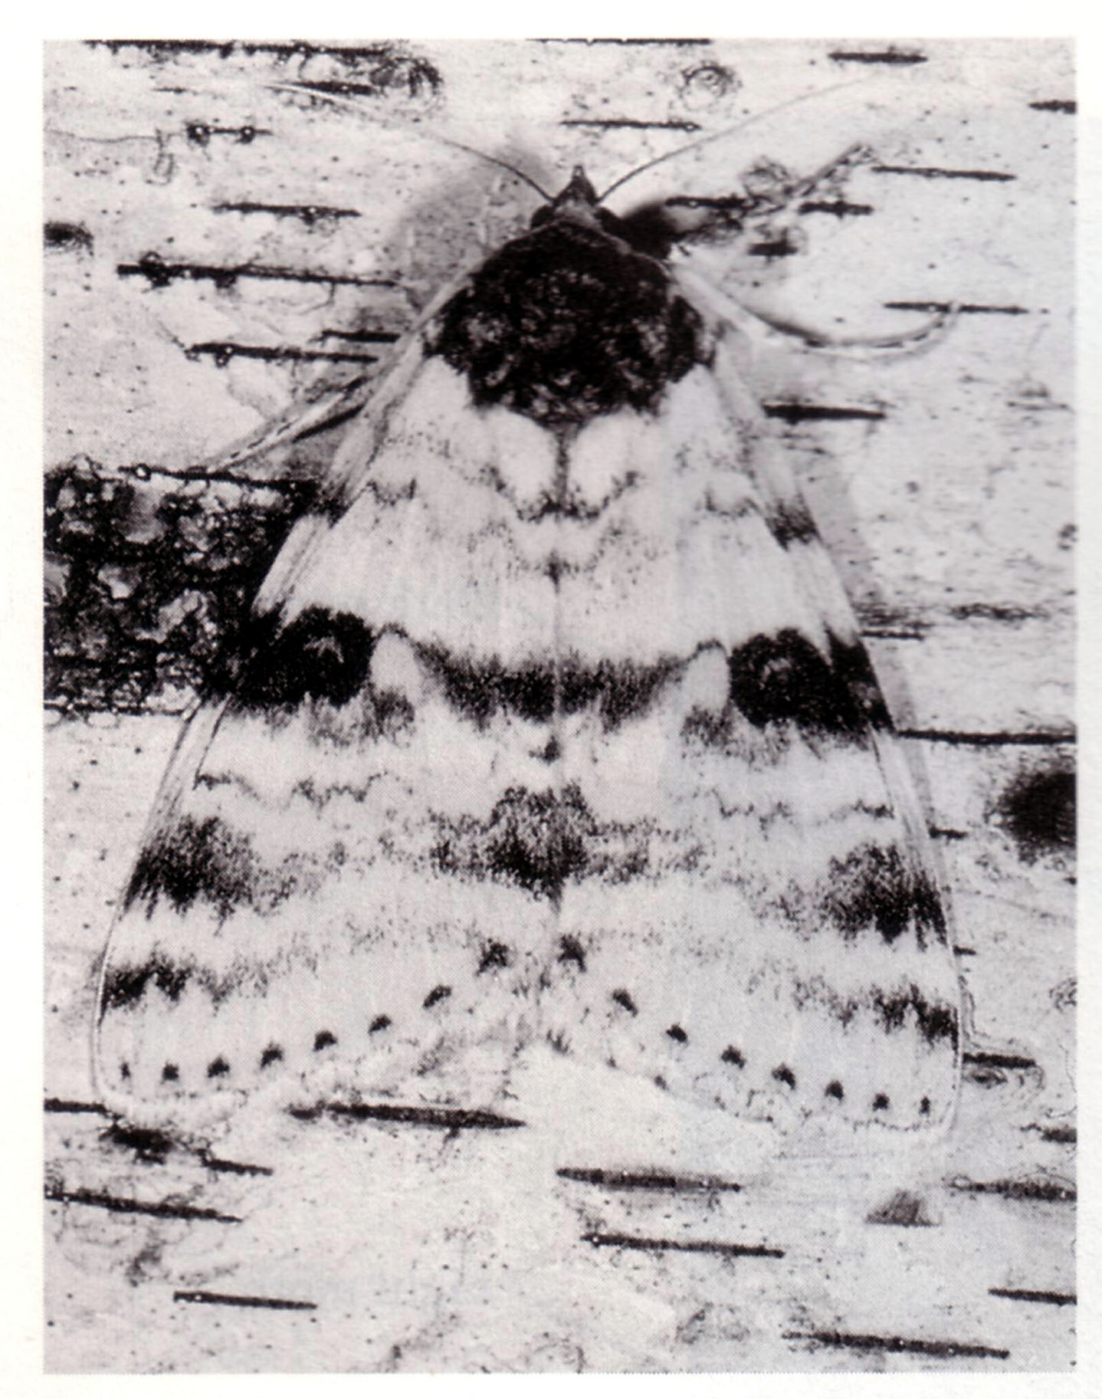
1. The image to the right shows a moth sitting on a tree common to its environment (birch tree). The image shows the actual color pattern and size of the moth. Birds are one predator of this moth.

A. Hypothesize why the moth looks the way it does. (half a point)

B. If you could make unlimited observations of this moth in the field,
EXPLAIN ONE observation that would support your hypothesis in A.
(half a point)

C. Design an experiment to test your hypothesis. You MUST include and identify: (2 points)
1. the independent variable(s)
2. the dependent variable(s)
3. one outcome that, if seen, supports your hypothesis
4. one outcome that, if seen, does NOT support your hypothesis

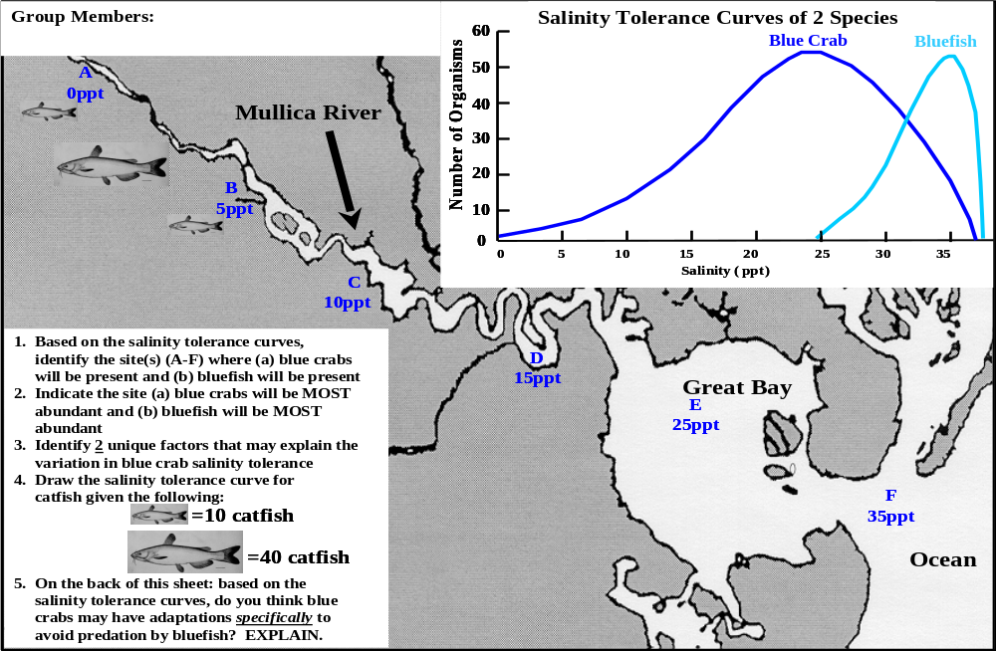
BIO 115 Group Activity #2

