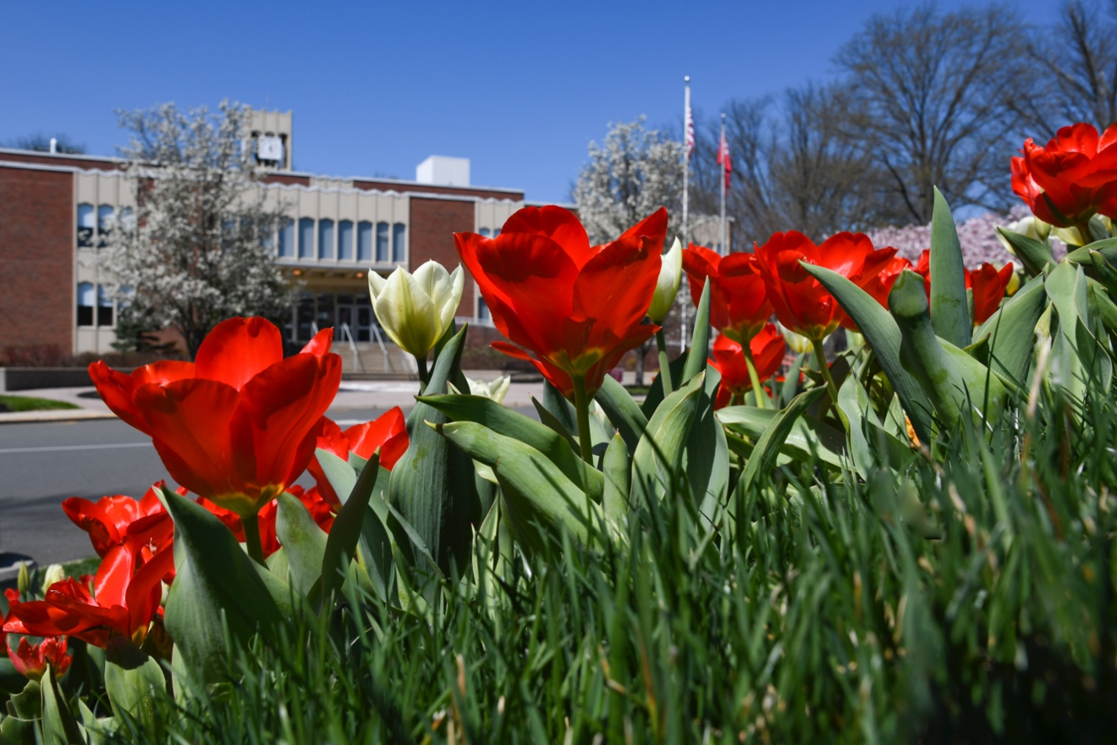
Fun Campus

Event

May 1 | 3 p.m.

Campus Mall
Join us for food, music and games on the Campus Mall!

Learn more and register at:

rider.edu/url

